DT021-1 Electrical Machine and Power Electronics

POWER ELECTRONICS Lecture 1: Power Conversion

Topics Covered:

- Power Electronics is about converting electrical energy from one form into another.

- Types of Conversion:
  - Rectifier: Converting AC to DC. Examples: Power supply in a desktop computer. A battery Charger
  - Inverter: Converting DC to AC. Examples: AC supply for mobile home running from a car battery.
  - DC to DC: Example internal power supply in a laptop producing various voltages from the battery voltage.
  - AC to AC: Convert from one AC voltage and frequency to another voltage and frequency. This is the most complex conversion and is usually accomplished by means of a DC link: AC to DC followed by DC to AC. Examples include: Variable Speed Motor Drives
- Efficiency and losses:
  - Efficiency = Pout/Pin
  - Losses = Pout-Pin. Losses usually manifest themselves as heat
- Linear conversion versus switch mode conversion:
  - In Linear conversion the transistors are used in their linear region much like variable resistors. This can be used to give smooth accurate control of output voltage but transistor losses are high and efficiency is poor.
  - In switch mode conversion transistors are used as switches – either on or off. When a switch is closed the current is high but the voltage across it is zero => very low losses. When a switch is open the voltage across it is high but the current through it is zero => no losses. Switch mode power supplies have excellent efficieny (100% in theory, 80-95% in practise) but suffer from ripple. Filters are used to reduce the ripple to acceptable levels.

In modern applications switch mode conversion is always used except at low power levels where efficiency is not important and specialist applications (eg audio amplifers) where ripple would be unacceptable.

Comparison of Linear and Switch Mode DC/DC conversion 10V in and 5V out

1. Simple Linear Regulator
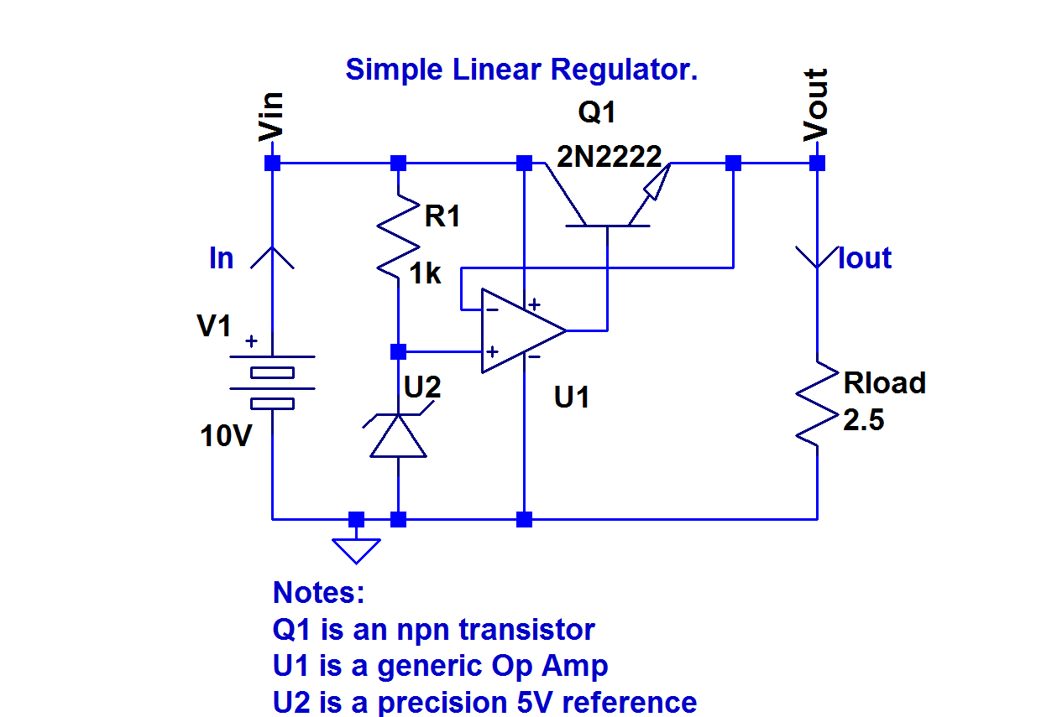

The controller (Op Amp) compares the output voltage to the 5V precision reference. If the output is less than 5V then the op Amp increases the base current of Q1 causing the transistor impedance to decrease and causing the output voltage to rise. If the output voltage is too high then the base current is reduced and the output falls. This negative feedback control loop will force the output voltage to stabilise at exactly 5V.

Let Iq=the quiescent current comprised of the current drawn from the input rail by by R1 and the various inputs of U2. In a well designed regulator this current will be very small.

Iin=Iout+Iq
Efficiency=Pout/Pin = (Vin*(Iout+Iq))/Vout*Iout)

If Iq<<Iout then

Efficiency = (Vout.Iout)/(Vin.Iout) = Vout/Vin = 0.5

This low efficiency (which can be even worse if Vout is lower) is a major reason why linear regulators have fallen out of fashion in recent year. They can still b eused to provide a cheap reliable DC/DC converter in low power applications where efficiency is not a consideration.
2. Switch Mode Regulator (Buck Converter)
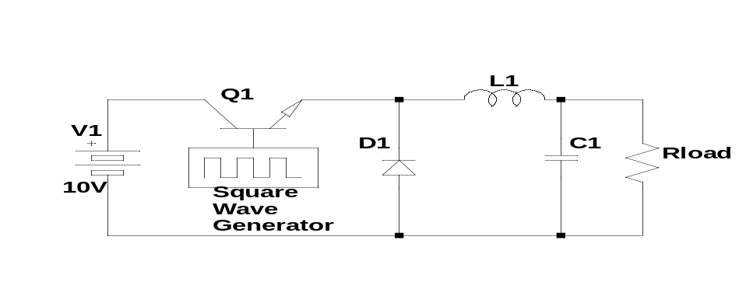
The square wave base drive turns Q1 fully on 50% of the time and fully off 50% of the time. When Q1 is on the cathode of D1 is at 10V when Q1 is off the cathode is at 0V. Thus the voltage at the cathode of D1 is a square wave from 0 to 10V with 50% duty cycle. L1 and C1 form a filter which smoothes out this square wave leaving an average voltage of 5V across the load. The losses in the transistor are very small because it is operating as a switch and the losses in L1 and C1 are theoretically zero so the switch mode converter has a theoretical efficiency of 100%. The output voltage will have ripple on it however depending on the size of L1 and C1.

The diode D1 is called a freewheel diode and is required to provide a path for the current flowing in L1 when the switch opens. If there were no freewheel diode then there would be very high induced voltages generated by L1 when Q1 tried to interrupt the current.

The second order filter comosed of L1 and C1 filters the rippe and produces a smooth output voltage which is the average of the voltage across D1. Neglecting the small on state voltage drops across thw switch Q1 and diode D1this voltage will be =V1 when the switch is on and =0V when the switch is off.

The output voltage = D*Vin where D is the proportion of time that the switch is on (called the duty cycle).

